Oshawa Area Scouts Invites You to a
Haunted Halloween Hike

Saturday, October 29, 2016 6:30pm-9:00pm

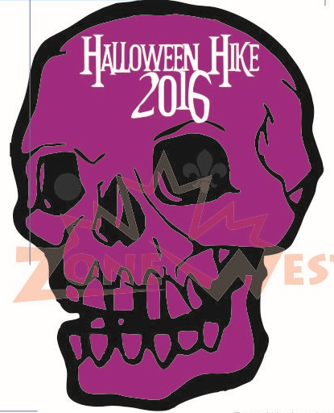

Group name |  |  | Email:
Number of Participants:
Preferred Time: | 6:30-7:00 | 7:00-7:30 |  | 7:30-8:00 | 8:00-8:30 | 8:30-9:00

Cost: $6.00 per participant

Only the first 200 registered will receive a crest.
Don’t be disappointed.

Registration can be left in the folder at the scout administration building at Samac or mailed to:
Jamie Caswell 1854 Woodgate court, Oshawa On, L1G 7Z2
Email jncaswell@rogers.com
Notes
- Cheques must be payable to Scouts Canada – 21st Oshawa Group
- Registrations are non-refundable
- Late registrations are subject to availability
- Haunted Hike will be age appropriate (8-10) younger and older are accepted as well
- All participants must be registered members of Scouts Canada or Girl Guides of Canada
- No registrations will be accepted prior to September 19, 2016
- Paid participants will received blanket crest (first 200 only) and goodie bag for all

