Tri-Area Winter Activity Day
THEME (To Be Announced)
Yes the date will be 2018 on the actual crest
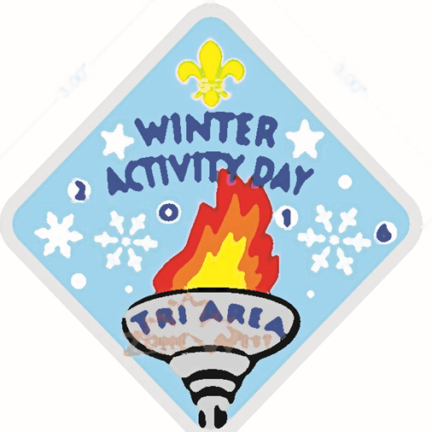
Saturday, February 3, 2018
10:00am – 3:30pm
at Camp Samac
(Registration 9:00 – 9:30)
Method of Payment:
- Cheques must be payable to Scouts Canada – Oshawa Area Events
- Registrations may be mailed to: Debbie Caswell 949 Langford St. Oshawa On L1K 0A5 or left in the folder at the scout shop.
- Registrations is open to all Cub Packs and Brownies and is non-refundable
- Cost is $12.00 per youth
- This event will is limited to the first 200 youth paid in full.
- Free crests will be given to leaders using the standard ratio of 6:1
  - Additional leader crests are available for $5.00 while supplies last
- Lunch is provided; dress appropriate for the weather- all events are outdoors

Registration:
Group: . Contact: .
Phone: . Email: .
Number of Leaders: . Number of Youth: .
Additional Leader Crests: .

